New controller: Two sensors
and a pressure range up to 210 bar

Klingenberg, August 2015.

WIKA has designed the CPC4000 pneumatic pressure controller for a wide spectrum of applications. The new calibration instrument is also a cost-effective alternative to high-end solutions.

Within the product portfolio, the CPC4000 replaces the CPC3000 high-speed pressure controller. It offers an addition to the functions and performance and, with a control speed of up to ten seconds, is still relatively fast. The new controller has an extended pressure range of up to 210 bar (3,045 psi). It can be fitted with two reference pressure sensors, which are controlled automatically in accordance with the calibration task. The sensors also work with an improved accuracy of 0.02 % FS or, optionally, 0.02 % IS-50. The intuitive operation of the new controller via a 7" LCD colour touchscreen corresponds to the concept of the entire product family.

The CPC4000 serves mainly as a reference instrument in the production of low-cost pressure sensors as well as in the oil and gas industry. As a result of the rate regulation, which is now available, it can also test and check pressure switches.

Number of characters: 1090

Key word: CPC4000

Manufacturer:
WIKA Alexander Wiegand SE & Co. KG
Alexander-Wiegand-Straße 30
63911 Klingenberg/Germany
Tel. +49 9372 132-0
Fax +49 9372 132-406
vertrieb@wika.com
www.wika.de

WIKA company photograph:
Pressure controller CPC4000

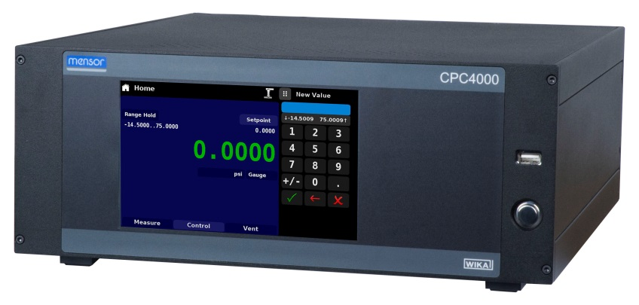

Edited by:
WIKA Alexander Wiegand SE & Co. KG
André Habel Nunes
Marketing Services
Alexander-Wiegand-Straße 30
63911 Klingenberg/Germany
Tel. +49 9372 132-8010
Fax +49 9372 132-8008010
andre.habel-nunes@wika.com
www.wika.de

WIKA press release 20/2015

