Through the serial number
direct to the product data

Klingenberg, May 2014.
WIKA has set up a new internet service for users of both model A-10 and model S-20 pressure transmitters: All individual product data are now available on the microsite https://portal.wika.com/serial/.

Customers can retrieve the information either by entering the serial number, or – just recently – a QR code on the included test report. This way, they get a direct access to all item details, links to the data sheet and operating instructions as well as the ability to download test reports and certificates. A successful access to the new web application also confirms that the instrument supplied is an original product from WIKA.

Number of characters: 708
Key words: Microsite serial number

Manufacturer:
WIKA Alexander Wiegand SE & Co. KG
Alexander-Wiegand-Straße 30
63911 Klingenberg/Germany
Tel. +49 9372 132-0
Fax: +49 9372 132-406
vertrieb@wika.com
www.wika.com

WIKA company photograph:
“Intelligent” serial number for WIKA pressure transmitters

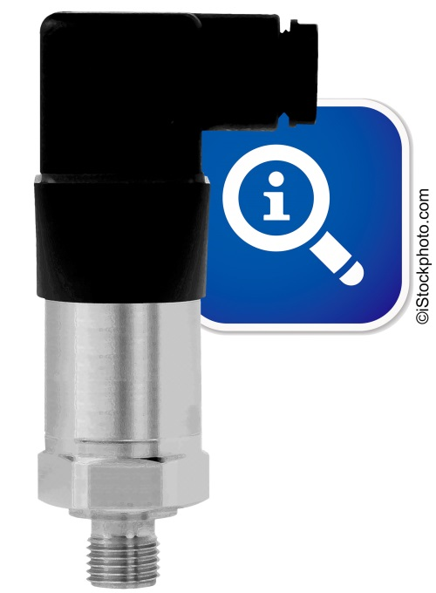

Edited by:
WIKA Alexander Wiegand SE & Co. KG
André Habel Nunes
Marketing Services
Alexander-Wiegand-Straße 30
63911 Klingenberg/Germany
Tel. +49 9372 132-8010
Fax: +49 9372 132-8008010
andre.habel-nunes@wika.com
www.wika.com

WIKA press release 07/2014

