New flange monoblock
with shut-off valve
Klingenberg, January 2021. WIKA's new monoblock with flange connection has been designed for applications in the process industry. The compact design integrates a shut-off valve to separate the process from the instrument side.

The one-piece construction and the double sealing (metal and plastic), tested in accordance with BS6755 / ISO 5208 leakage rate A, give the compact instrument the greatest possible safety. Its high-quality manufacture ensures smooth handling, even at high process pressures. The model IBF1 can be fitted with either a ball valve or needle valve.

The new instrumentation valve complements the existing monoblock portfolio which includes the models IBF2 (block & bleed) and IBF3 (double block & bleed). On request, WIKA supplies a customer-specific assembly of measuring instrument and monoblock (“instrument hook-up”), ready for operation and leak-tested. All IBF models can also be fitted on level indicators and differential pressure measuring instruments for level measurement.

Number of characters: 980
Key word: IBF1

Manufacturer:
WIKA Alexander Wiegand SE & Co. KG
Alexander-Wiegand-Straße 30
63911 Klingenberg/Germany
Tel. +49 9372 132-0
Fax +49 9372 132-406
vertrieb@wika.com
www.wika.de

WIKA company photograph:
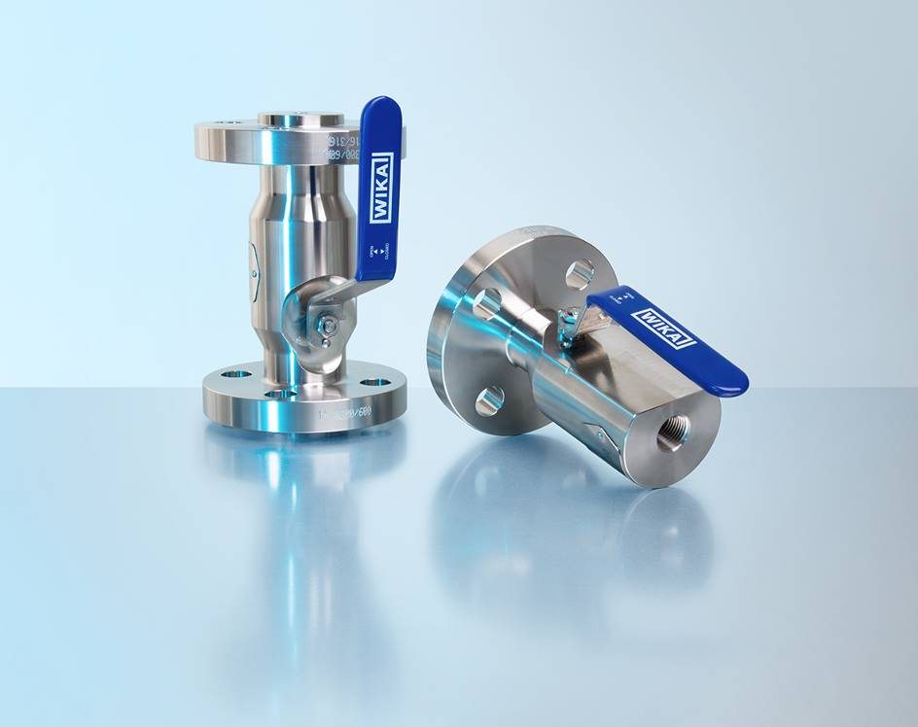
Model: IBF1

Edited by:
WIKA Alexander Wiegand SE & Co. KG
André Habel Nunes
Marketing Services
Alexander-Wiegand-Straße 30
63911 Klingenberg/Germany
Tel. +49 9372 132-8010
andre.habel-nunes@wika.com
www.wika.de

WIKA press release

