Universal process transmitter
with global hazardous area approvals

Klingenberg, June 2015.
The safety of the UPT-2x process transmitter from WIKA is certified globally: The universal instrument has achieved approvals for use in hazardous areas in accordance with IECEx, ATEX and now also EAC.

The multi-functional UPT-2x is a solution for tasks in pressure, level and volume measurement. Its sensor, with a measuring range between 0 ... 400 mbar and 0 ... 1000 bar depending on the requirement, operates with an accuracy of up to 0.1 % of the measuring span. For applications in the pharmaceutical and food industries, flush-mounting versions are available. The electronics are protected by a conductive plastic case, or optionally by a stainless steel case in hygienic design.

The measuring ranges of the UPT-2x are freely scalable and can therefore be adjusted to individual measurement tasks. An intuitive-to-use menu in accordance with the HART®-v7 standard and the integrated display make programming easier. With its handling without the need for tools, its high long-term stability and its universal application possibilities, the UPT-2x is also a cost-effective solution.

Number of characters: 1086
Key word: UPT-2x

Manufacturer:
WIKA Alexander Wiegand SE & Co. KG
Alexander-Wiegand-Straße 30
63911 Klingenberg/Germany
Tel. +49 9372 132-0
Fax +49 9372 132-406
vertrieb@wika.com
www.wika.com

WIKA company photograph:
WIKA process transmitter UPT-2x

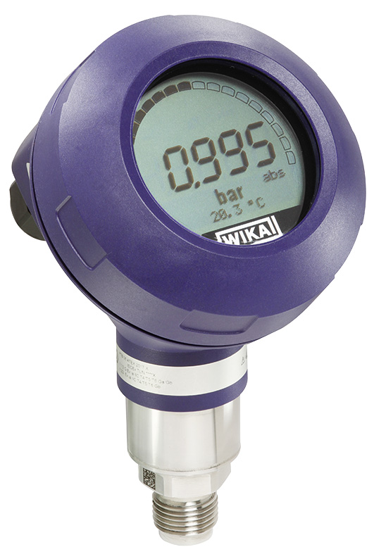

Edited by:
WIKA Alexander Wiegand SE & Co. KG
André Habel Nunes
Marketing Services
Alexander-Wiegand-Straße 30
63911 Klingenberg/Germany
Tel. +49 9372 132-8010
Fax +49 9372 132-8008010
andre.habel-nunes@wika.com
www.wika.com

WIKA press release 14/2015

