Hygienic stainless steel case
for the UPT-21 universal transmitter

Klingenberg, April 2015.
WIKA has extended the application spectrum of the UPT-21 universal process transmitter. The pressure measuring instrument is now also available with a robust and simultaneously hygienic stainless steel case, with an electropolished surface as an option.

The UPT-21 with its rotatable display head (60 mm display) is optimally sealed in any mounting position. Case and electrical process connection have external seals that remain free from deposits. The glands of the cable entry feature a smooth external surface and internal threads for the cable clamps. They are thus ideally suited to washdown. For hygienic applications, process connections are available with clamps, milk thread fittings and sterile flanges.

As with the case design, the measurement electronics of the transmitter, which communicates via HART® protocol (V7), have been designed for operational versatility. The compact instrument, depending on the requirement, is fitted with a sensor between
0 ... 400 mbar and 0 ... 600 bar, which measures with an accuracy of up to 0.1 % of the span. The measuring ranges are freely scalable and thus easy to set to all intermediate pressure ranges. The UPT is built in accordance with the 3-A Sanitary Standards and also explosion-protected in accordance with ATEX, IECEx, Inmetro and EAC approvals.

Number of characters: 1307
Key words: UPT-21 with hygienic design

Manufacturer:
WIKA Alexander Wiegand SE & Co. KG
Alexander-Wiegand-Straße 30
63911 Klingenberg/Germany
Tel. +49 9372 132-0
Fax +49 9372 132-406
vertrieb@wika.com
www.wika.de

WIKA company photograph:
Universal transmitter UPT-21 with hygienic design

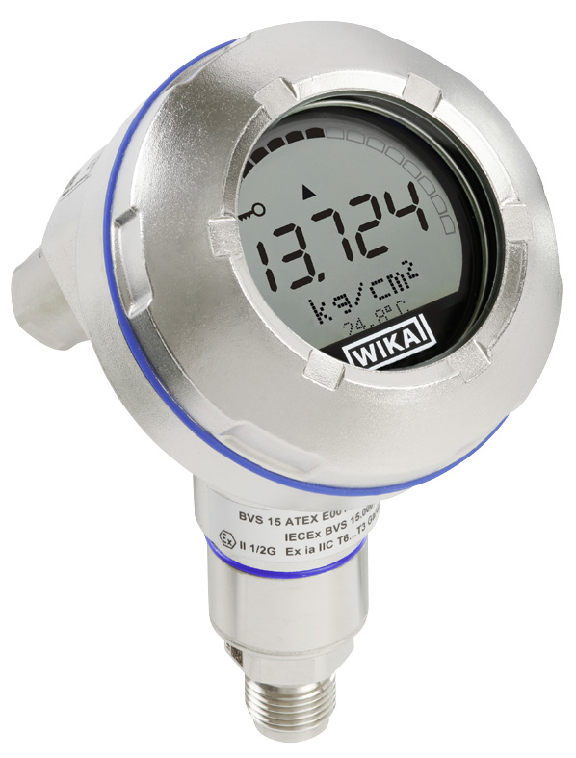

Edited by:
WIKA Alexander Wiegand SE & Co. KG
André Habel Nunes
Marketing Services
Alexander-Wiegand-Straße 30
63911 Klingenberg/Germany
Tel. +49 9372 132-8010
Fax +49 9372 132-8008010
andre.habel-nunes@wika.com
www.wika.de

WIKA press release 05/2016

